ENEL 420 Advanced Signals

Department of Electrical and Electronic Engineering

University of Canterbury

Assignment 1

IIR and FIR Filters for ECG Signals

GROUP 19

Pakorn Arunchayanon (xxxxxxxx)

Sasiru Goonatillake (51643980)

Abstract

Abstract about the ENEL420 assignment 1 regarding using IIR and FIR filters for ECG. Abstract about the ENEL420 assignment 1 regarding using IIR and FIR filters for ECG. Abstract about the ENEL420 assignment 1 regarding using IIR and FIR filters for ECG Abstract about the ENEL420 assignment 1 regarding using IIR and FIR filters for ECG Abstract about the ENEL420 assignment 1 regarding using IIR and FIR filters for ECG Abstract about the ENEL420 assignment 1 regarding using IIR and FIR filters for ECG Abstract about the ENEL420 assignment 1 regarding using IIR and FIR filters for ECG Abstract about the ENEL420 assignment 1 regarding using IIR and FIR filters for ECG Abstract about the ENEL420 assignment 1 regarding using IIR and FIR filters for ECG Abstract about the ENEL420 assignment 1 regarding using IIR and FIR filters for ECG Abstract about the ENEL420 assignment 1 regarding using IIR and FIR filters for ECG Abstract about the ENEL420 assignment 1 regarding using IIR and FIR filters for ECG Abstract about the ENEL420 assignment 1 regarding using IIR and FIR filters for ECG Abstract about the ENEL420 assignment 1 regarding using IIR and FIR filters for ECG Abstract about the ENEL420 assignment 1 regarding using IIR and FIR filters for ECG.

Table of Contents

Abstract 2

1 Introduction 3

2 Discussion of Tasks 4

2.1 Task 1 4

2.2 Task 2 5

2.3 Task 3 6

2.4 Task 4 6

2.5 Task 5 7

2.5.1 FIR Window Filter 7

2.5.2 FIR Optimal Method Filter 7

2.5.3 FIR Frequency Sampling Filter 7

2.6 Task 6 7

3 Conclusion 7

4 References 8

# Introduction

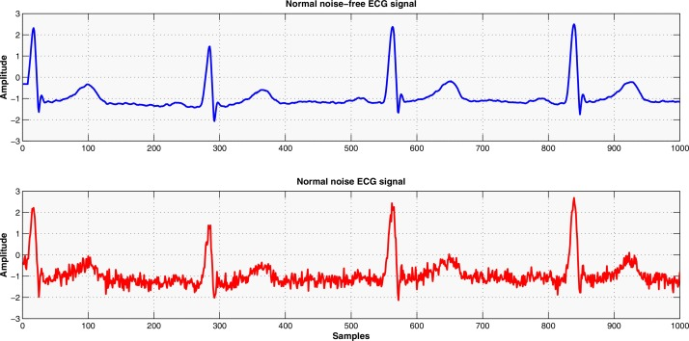Noise, in signal processing, is a general term for unknown or unwanted modifications to a signal during capture, transmission, conversion, storage, or processing. Electrocardiogram (ECG) is a signal that expresses the electrical activity of the heart, generated by contractions and relaxations of the heart. A regular ECG signal of a healthy human is shown below in Figure 1. ECG signals are captured using electrodes (transducers) placed on particular places on the body. [1] Noise is added to the ECG signal during signal capture (sensor), transmission (cables, wires), processing (electromagnetic interference) and additive noise. [2] These unwanted artefacts (noise) in an ECG signal hinder medical personnel from making an accurate diagnosis. Therefore, it is crucial to remove these from the signal using signal processing methods.

Figure : A clean ECG Signal of a healthy subject (noise removed) [3]

In this assignment, the team is given a data file containing an ECG signal corrupted by two additive noise frequencies between 30 Hertz (Hz) and 100 Hz. The team is required to detect and remove the two additive interferences (noise) from the signal using spectral analysis, designing and implementing notch filters. This assignment will give practical experience in understanding and analysing signals and processing them using digital techniques (digital filters) such as Infinite Impulse Response (IIR) and Finite Impulse Response (FIR) filters.

# Discussion of Tasks

## Task 1

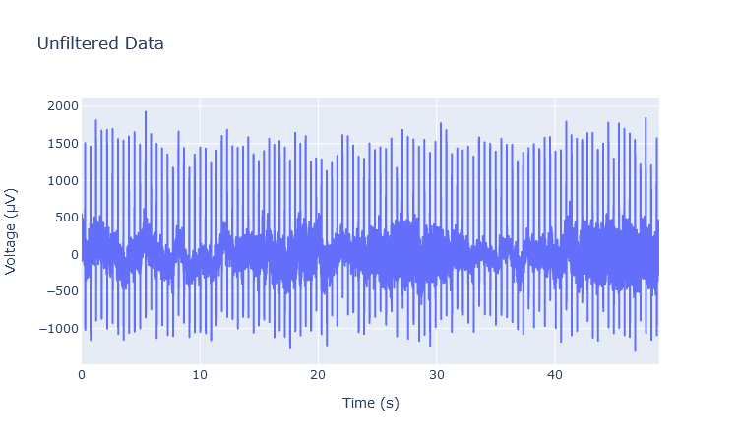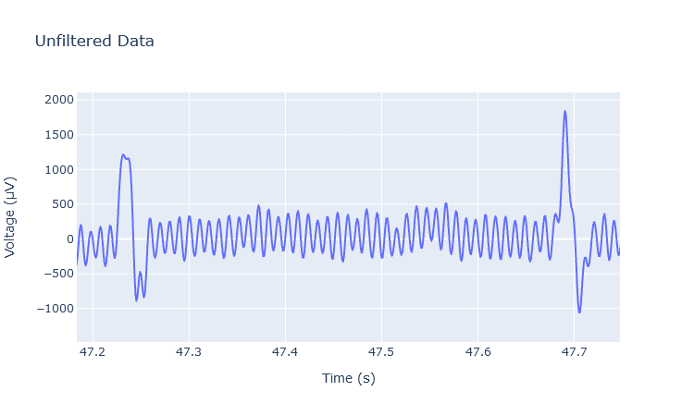

Figure : Unfiltered ECG data, Voltage vs Time

Figure : Expanded unfiltered data to showcase the shape of the signal.

## Task 2

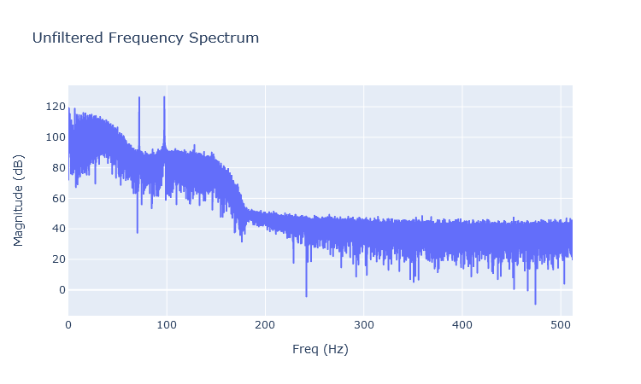

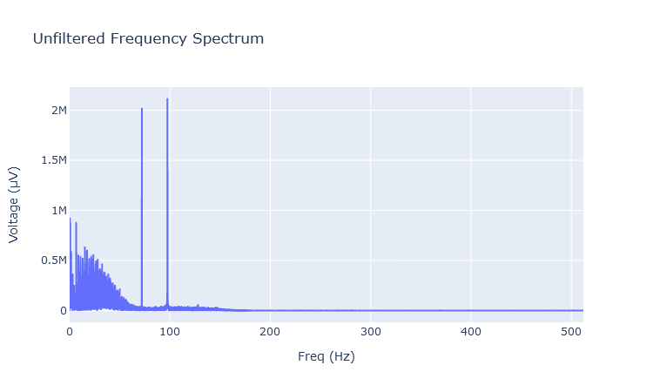

## Task 3

## Task 4

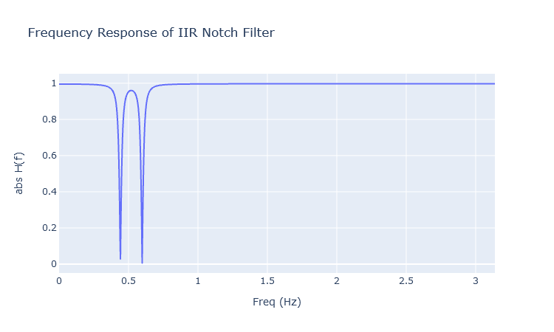

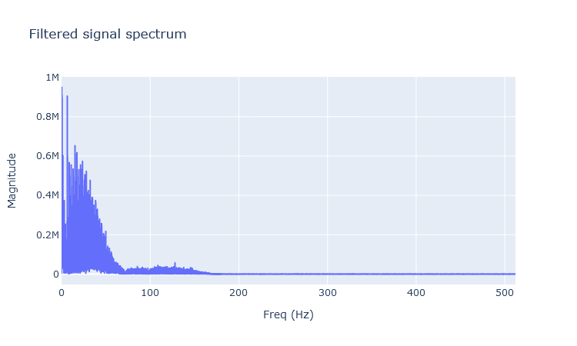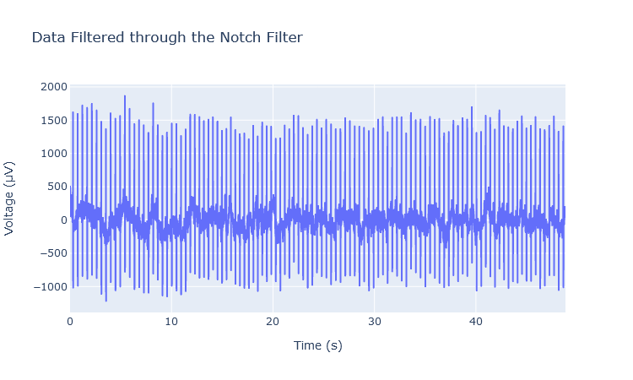

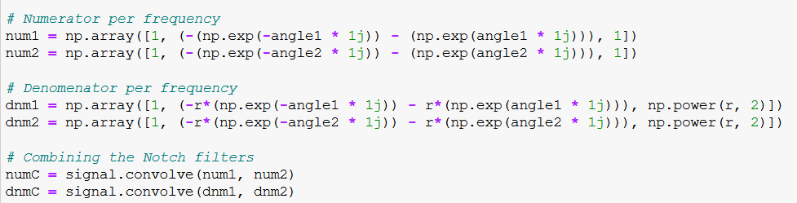

## Task 5

### FIR Window Filter

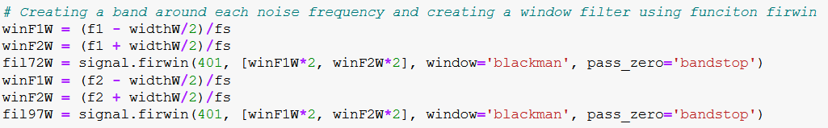

### FIR Optimal Method Filter

### FIR Frequency Sampling Filter

## Task 6

# Conclusion

# References

|  |  |
| --- | --- |
| [1] | ECG & ECHO, “The ECG leads: electrodes, limb leads, chest (precordial) leads, 12-Lead ECG (EKG) – ECG & ECHO,” ECG & ECHO, [Online]. Available: https://ecgwaves.com/topic/ekg-ecg-leads-electrodes-systems-limb-chest-precordial/. [Accessed 13 August 2020]. |
| [2] | R. Kher, “jscholaronline.org,” 12 March 2019. [Online]. Available: http://www.jscholaronline.org/articles/JBER/Signal-Processing.pdf. [Accessed 13 August 2020]. |
| [3] | Z. A. A. A. A. T. K. M. A.-B. M. A. Awadallahd, “Hybridizing β-hill climbing with wavelet transform for denoising ECG signals,” 15 November 2017. [Online]. Available: https://www.sciencedirect.com/science/article/pii/S0020025517310940. |